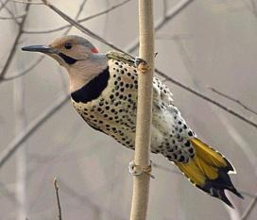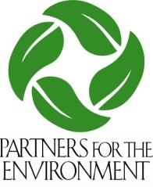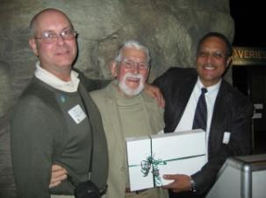

**2025 Membership Form**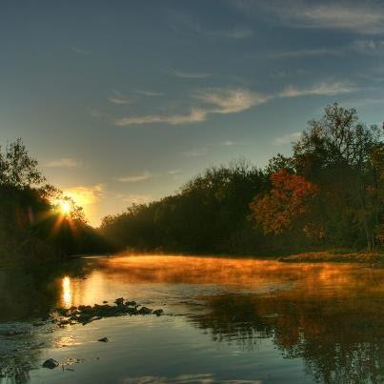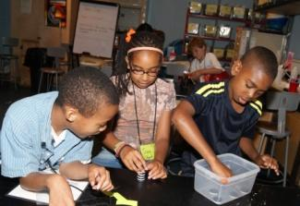

**Who are the Partners?**

The Partners for the Environment is an alliance of nonprofit organizations, government and civic groups, businesses and public and private educational institutions that work within the communities of the Great Miami River and Little Miami River watersheds to promote “green” initiatives.

Any organization that works to protect, restore, preserve, and promote the environmental and agricultural resources and is interested in leveraging and maximizing their resources to further those goals is welcome to become a Partner.

**Benefits of becoming a Partner**

• Free Partner meetings, including annual Awards Event

• Discounted training opportunities

• Opportunity to be recognized through Partner of the Year awards

• Monthly newsletters with announcements, events, and grant and training opportunities

• Promotion of your organization’s programs, activities, and media

• Strategic partnership with Dayton Regional Green

**Join today!**

* **Partner- $50 annually**
* **Supporting Partner - $500 annually -** Supporting Partners also receive extensive recognition at events, on the website and through other media materials.

**Send your contact information and annual payment to:**

Partners for the Environment

38 E. Monument Avenue, Dayton, Ohio 45402

(937) 223-1278 X3210

[admin@gdpartners.org](mailto:admin@gdpartners.org)

Checks payable to: Partners for the Environment Fund of The Dayton Foundation

Name Title

Organization

Street Address

City State Zip Phone

Email Website Twitter

Check one: ◻Partner- $50 annually ◻Supporting Partner - $500 annually